My Environment Set Up

I will be going over my environment for writing simple (vanilla) JavaScript, HTML, and css (No frameworks).

Generally, as far as all-purpose code editing, I suggest you use ( <https://code.visualstudio.com/> )

Now in visual studio, create a directory(PROJECT_STARTER). Visual Studio and create the following files:

In the index.html file, enter !+Enter to create the following:

<!DOCTYPE html>

<html lang="en">

<head>

    <meta charset="UTF-8">

    <meta name="viewport" content="width=device-width, initial-scale=1.0">

    <title>Document</title>

</head>

<body>

</body>

</html>

Next, I want to go over some information about extensions. Emet is a pre-installed tool when you finish setting up Visual Studio. If you are using an alternative like sublime text, you must install Emet. All this extension does is help you write html significantly faster. For example, If you want a h1 tag, you type need to type h1+Enter.

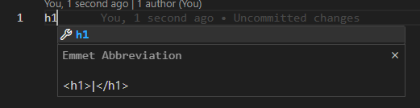

If I want a class I can enter h1.myclass+Enter :

<h1 class="myclass"></h1>

If I want two classes I enter h1.myclass.myclass2+Enter: 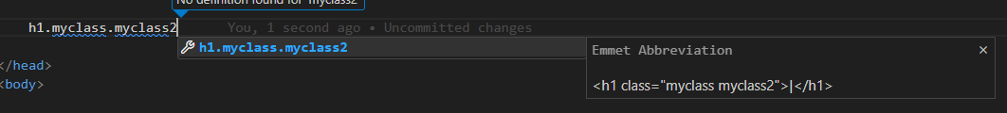

<h1 class="myclass myclass2"></h1>

One alternative syntax for creating a div is div.myclass+Enter, which displays myclass. But the preferred syntax is .myclass+Enter:

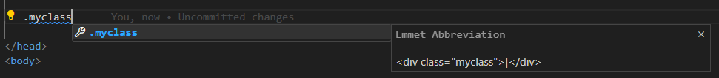

<div class="myclass"></div>

If we want three divs when can enter div*3+enter

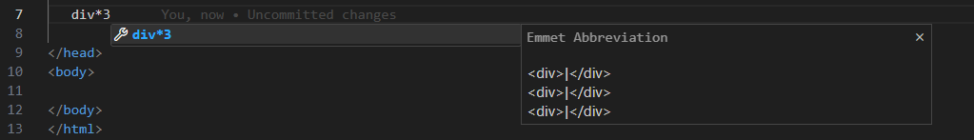

   <div></div>

   <div></div>

   <div></div>

If I want to do an ID, I can enter h#myid+Enter:

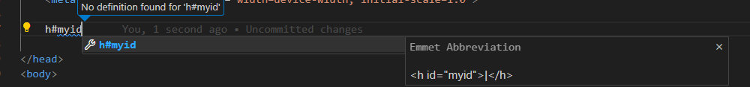

<h id="myid"></h>

Recommended Extensions you install:

**Live Server -(**[**https://marketplace.visualstudio.com/items?itemName=ritwickdey.LiveServer**](https://marketplace.visualstudio.com/items?itemName=ritwickdey.LiveServer)**)**

This will allow us to deploy a local server to are web browser and automatically update whenever me make a change to either are HTML CSS or JavaScript :

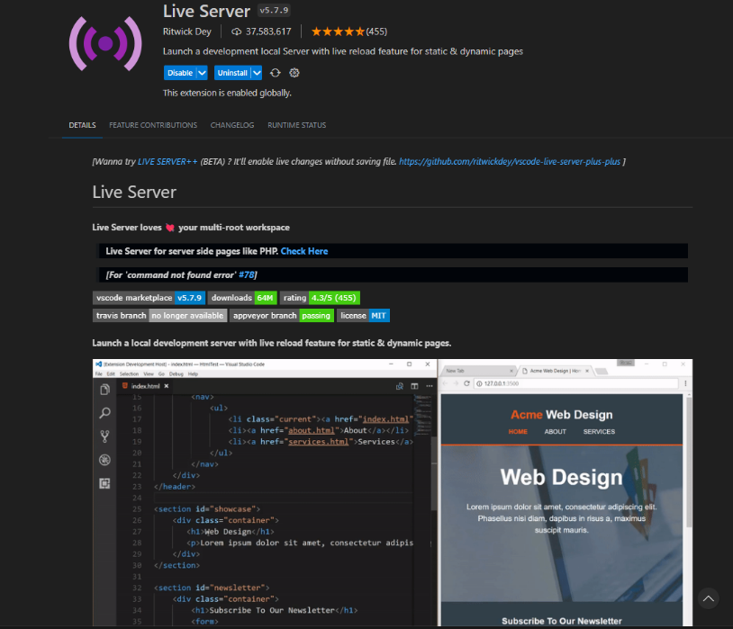

**Auto Rename Tag – (**[**https://marketplace.visualstudio.com/items?itemName=formulahendry.auto-rename-tag**](https://marketplace.visualstudio.com/items?itemName=formulahendry.auto-rename-tag)**)**

This extension automatically renames the associated tag when one is changed.

**Bracket Pair Colorizer – (**[**https://marketplace.visualstudio.com/items?itemName=dzhavat.bracket-pair-toggler**](https://marketplace.visualstudio.com/items?itemName=dzhavat.bracket-pair-toggler)**)**

Gives your brackets, parentheses and curly braces Colorization

**Prettier – Coder formatter(**[**https://marketplace.visualstudio.com/items?itemName=esbenp.prettier-vscode**](https://marketplace.visualstudio.com/items?itemName=esbenp.prettier-vscode)**)**

Automatically formats the whitespaces in your code. You can also configure more settings for any extension mentioned by navigating to the gear icon and searching for said extension. For example if we

Other Tools I use

Note: A lot of the tools mentioned are from videos, so I will link the source for your viewing leisure; I will include the most pertinent for ITSE-1301. For the full List: (<https://www.youtube.com/watch?v=0EtgwIajVqs>).

**Chocolately – (** [**https://community.chocolatey.org/**](https://community.chocolatey.org/) **)**

A package manager for the quick installation of common apps, code dependencies, drivers, and more. It is command based (don’t be scared you can use a GUI to create a sequence of apps to install all at once).

**// INSTRUCTORS NOTE: PLEASE FOR THE LOVE OF GOD ASK IT ABOUT THIS BEFORE YOU STUDENTS GET IN TROUBLE!!**

**Simple HTTP Server – (** [**https://github.com/TheWaWaR/simple-http-server**](https://github.com/TheWaWaR/simple-http-server) **)**

If you and your web developer buddy are on the same network and are looking to exchange files without the use of a database service, or a flash drive, I recommend using this HTTP server. Simply place the server into the file you wish to associate with a url, and now anyone that goes to it has access to the folder. Simple as. Please remember to turn this off once you’re done.

**(Windows only) Wintoys-(** [**https://apps.microsoft.com/store/detail/wintoys/9P8LTPGCBZXD**](https://apps.microsoft.com/store/detail/wintoys/9P8LTPGCBZXD) **)**

This is a utility that gathers services, utility, settings, and service management tools in Windows all in one place.

**Ventoy- (** [**https://www.ventoy.net/en/index.html**](https://www.ventoy.net/en/index.html) **)**

While you are writing code for this course, I expect at least one student to experience some sort of catastrophic computer error that causes their entire system to need a fresh operating system installation. I could be you! I recommend first having back a of your systems, and having a bootable thumb drive handy for reinstalling your OS of choice. Ventoy is a tool for creating bootable media for flash drives that supports multiple operating systems. You simply install and then drag and drop your iso image.

**NetBoot- (** [**https://netboot.xyz/**](https://netboot.xyz/) **)**

And if you are looking for an iso image to boot from, I recommend using netboot (PXE). It is a 2.3kb file that allows you to boot from over 80 operating system installers, liver operating systems, and utility images over the network (including Windows with a bit of work/ using a Windows PE environment).

**Medicat USB – (**[**https://medicatusb.com/**](https://medicatusb.com/) **)**

If this list seems long I recommend using medicat: this tool gathers all of the tools, and bootable media, including a Windows PE environment in a beefy 20 GB package (it needs a 32 GB thumb drive). I’m sticking my neck out for this one because this package includes some pirated material and tools that have been deemed as “hacking tools” so please don’t get into any trouble, but you won't tell on you if you don’t.